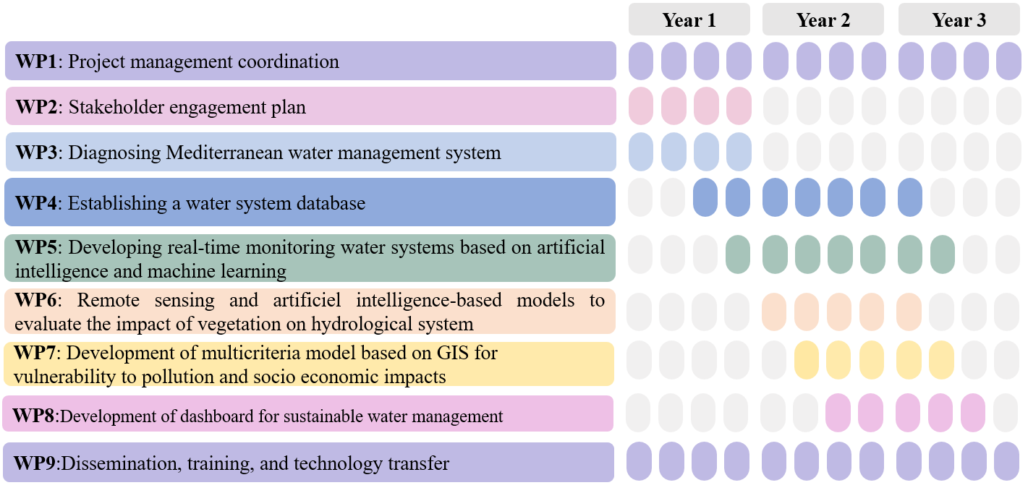
Figure 3.1a SAVE water Work packages Gantt chart

Table : List of Deliverables
Deliverable  (number) | Deliverable  Name | Work  package  number | Short  name of  lead  participant | Type | Dissemination  level | Delivery  date  (in  months)
D1.1. | Project Management Plan | 1 | FST-UTM | DEM | PU | M3
D1.2. | Ethics assessment report | 1 | FST-UTM | R | CO | M6
D1.3. | Midterm management report | 1 | FST-UTM | R | PU | M18
D1.4. | Final SAVE water project report | 1 | FST-UTM | R | PU | M36
D.2.1 | Stakeholder-data-set and report on the workshop and meetings | 2 | FST-UTM  USC | R | CO | M3
D.2.2 | Living lab events report | 2 | FST-UTM | R | PU | M6
D.2.3 | Ethics report | 2 | FST-UTM | R | CO | M6
D.2.4 | Gender action plan | 2 | Agriant | DEM | CO | M12
D3.1. | Data Collection and Analysis, water Demand report | 3 | UBMA | R | CO | M12
D3.2. | Policy and Governance Evaluation report | 3 | TU BERLIN | R | PU | M10
D3.3. | Water monitoring research studies limitations report | 3 | UBMA | R | PU | M12
D3.4. | Environmental Impact Assessment and Climate Change Considerations | 3 | FC.ID | DEM | PU | M24
D4.1 | Database design document | 4 | ISASI-CNR | R | CO | M18
D4.2 | A comprehensive collection of cleaned and standardized data sets | 4 | I SASI-CNR | DEM | CO | M21
D4.3 | A fully developed and functional database | 4 | ISASI-CNR | OTHER | CO | M27
D4.4 | A deployed and operational database | 4 | ISASI-CNR | OTHER | CO | M27
D5.1 | Water sensors development | 5 | MSE-UMA | DEM | CO | M24
D5.2 | Water sensors processing report | 5 | FST-UTM | R | CO | M30
D6.1. | SVAT and AI models | 6 | CIRAD | OTHER | CO | M30
D6.2. | A methodology to upscale different metric of the vegetation using remote sensing and AI | 6 | CIRAD  IAV | DEM | PU | M33
D7.1. | Multicriteria analysis report | 7 | FST-UTM | R | CO | M27
D7.2. | Water vulnerability model | 7 | FSTT | OTHER | CO | M30
D7.3. | Insurance program report | 7 | Agriant TU BERLIN | R | PU | M30
D7.4. | Policies and strategies Toolbox | 7 | FST-UTM, TU BERLIN | OTHER | CO | M30
D8.1. | Design Mockups and Prototypes | 8 | FST-UTM, FOAFU | DEM | PU | M21
D8.2. | Data Integration Framework | 8 | FOAFU | OTHER | CO | M27
D8.3. | Beta Version of the Dashboard | 8 | FOAFU  UBMA | DEC | PU | M30
D8.4. | User Feedback Report | 8 | FST-UTM | R | PU | M30
D8.5. | Final Dashboard and Deployment Report | 8 | FST-UTM FOAFU | R | PU | M33
D9.1 | Web site, platform | 9 | FST-UTM | DEC | PU | M3
D9.2 | Communication and Dissemination plan | 9 | TU BERLIN  USC | DEM | PU | M8
D9.3 | Dissemination of project results report | 9 | FST-UTM | R | CO | M33
D9.4 | Project exploitation and sustainability report | 9 | TU BERLIN | R | PU | M36

